Hi Sunny –

Sorry for the delay… I’ve known the next chart that I’ve wanted us to make… however, I recently double checked the process I was using to generate the data for it, and it turns out there were flaws in my method for generating the results. I’ve been working over the last week to fix these issues and I am happy to say that I’ve successfully been able to do so.

There is now a new table in the database named “forecast”. The table contains four columns:

Date, prediction_sharpe, prediction_pnl, prediction_std

The data in this table contains predictions for each of the three values for all dates in the table. I am using linear regression to come up with the predictions.

There are two different charts I am hoping to create using the data from this table.

Chart 1 – modification to the existing CSI chart.

I am hoping to add the historical values for “prediction_std” to the existing CSI chart. For this one, can the format of the values graphed be the same bar graph style as the “difference” value on the KDE chart? I’ve taken a screenshot of that chart below to highlight what I’m describing:

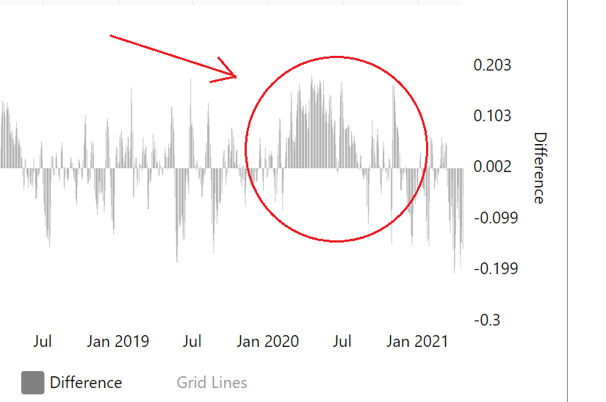

There is one additional feature I am hoping to implement for graphing the “prediction_std” value… can we add colors to the individual bars?

The table “ohlc_data1” contains a column named “quadrant”. This columns tells us the quadrant CSI was defined as for any given date. We have not taken advantage of this column yet – but I’m hoping to do so here.

For dates where CSI’s quadrant is either 1 or 4, can the bars plotted be green, and, for days where CSI’s quadrant is either 2 or 3, can the bars plotted be red?

Formatting…

1 - Axis

Can a third axis be added to the chart to represent this third piece of data graphed?

2 - Values

The values in prediction_std are meant to represent percents. So for example, a value of 0.20 is meant to represent “20% greater than usual”. Likewise, a value of -0.35 is intended to mean “35% less than usual”.

Because of this, is it possible to have the axis tick values be formatted as human readable percents like we have done in previous charts? (e.g., 10%, 20%, etc.)

3 – Name in legend and axis

Can we name the values graphed: “Volatility Forecast”

Chart 2 – Gauge

I would like to make three sgauge chart similar to the following example on amcharts: https://www.amcharts.com/demos/gauge-with-bands/

I am hoping to graph only the most recent day’s values in on the individual gauges.

There will a gauge for Sharpe Ratio, a gauge for PnL, and a gauge for Volatility.

1 - Colors

I am hoping to have each gauge have a color range from red to green – as before when we have graphed PnL and Volatility (standard deviation), red insinuates bad and green insinuates good.

For the Sharpe Ratio and PnL gauges, higher values are preferred – and therefore, a higher reading on the gauge will have the arrow pointing to the green side of the gauge.

For the Volatility (standard deviation), lower value are preferred – and therefore, a lower reading on the gauge will have the arrow pointing to the green side of the gauge.

2 – Gauge formatting (please see image below)

